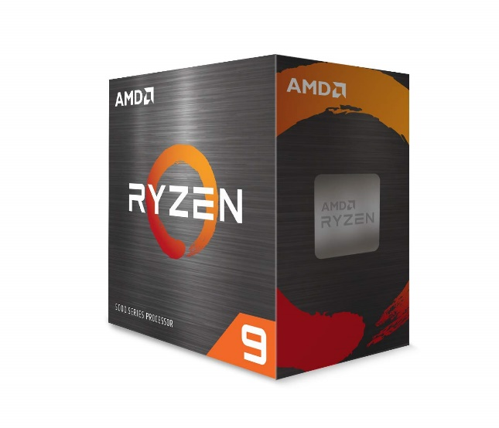

Inner

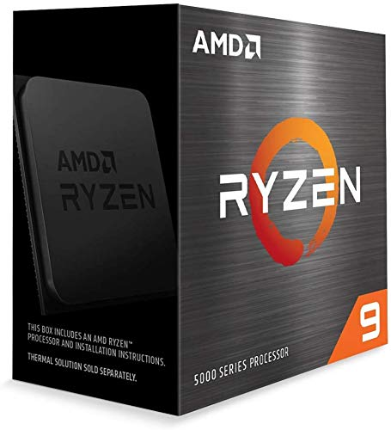

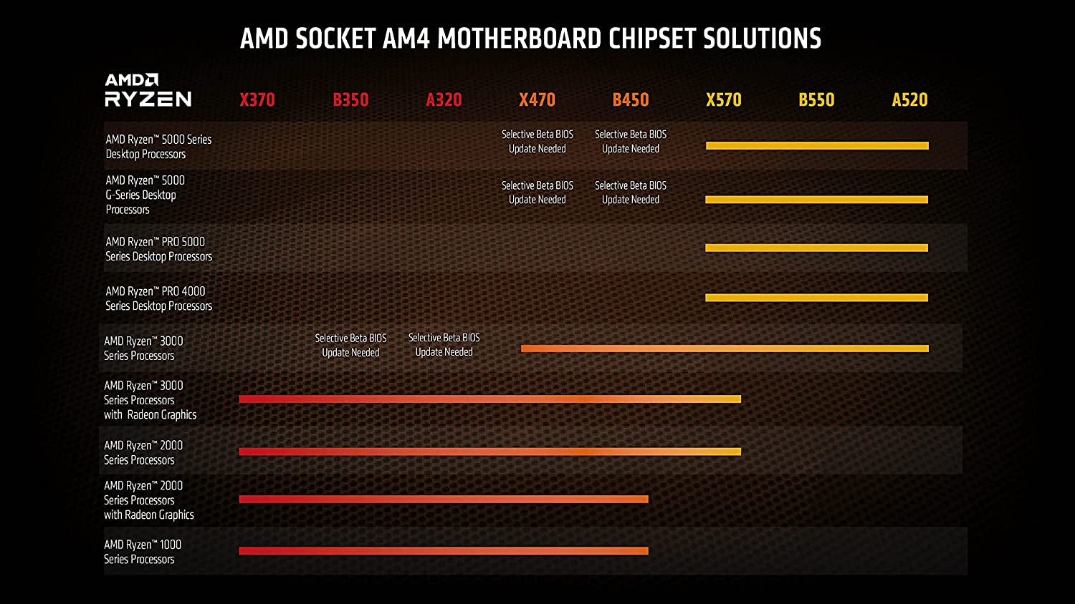

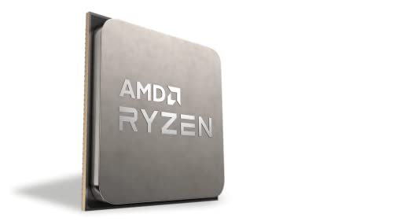

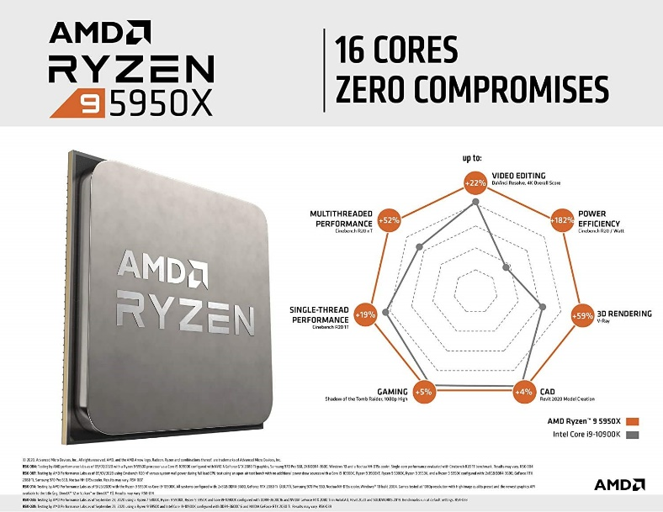

AMD 5000 Series Ryzen 9 5950X Desktop Processor 16 Cores 32 Threads 72 MB Cache 3.4 GHz up to 4.9 GHz AM4 Socket 500 Series chipset (100-100000059WOF)

|  |  |
| --- | --- |
| M.R.P.: | ₹1,14,000.00 |
| Deal of the Day: | ₹49,599.00   |  |  | | --- | --- | | Brand | AMD | | CPU Manufacturer | AMD | | CPU Model | Ryzen 9 | | CPU Speed | 3.4 GHz | | CPU Socket | Socket AM4 |   **About this item**   * 16 Cores & 32 Threads, 72 MB Cache * Base Clock: 3.4 GHz, Max Boost Clock: up to 4.9 GHz * Memory Support: DDR4 3200MHz, Memory Channels: 2, TDP: 105 W, PCI Express Generation : PCIe Gen 4 * Compatible with Motherboards based on 500 Series Chipset, Socket AM4 * Separate Graphic Card Required, Included Heatsink Fan: No * 3 Years Brand Warranty. For Technical Support : Please Contact : Tel: +91-80-67030050 (Mon-Fri: 09:00 - 17:00 IST); Expect Delayed Response due to ongoing COVID Crisis * For all performance-related issues in: AMD Processor: Please reach out via AMD brand home page > Drivers & Support > Customer Support  (Technical & Warranty help) > Contact Support > Online Service Request In case you are not satisfied the resolution provided by the above brands, please reach back to Amazon Customer service for next steps. |